LAPORAN PROYEK SCRUM

# BAB 1: PENDAHULUAN

## 1.1 Identitas Kelompok

Nama Kelompok: PEH

Kelas: IF-A Sore

Anggota :

1. 231110321 - Richi putra lin

2. 231111118 - Derry

3. 231112458 - Ahmad danu

4. 231112897 – Asyifa Alfath Kasman

5. 231112721 - Sherly

## 1.2 Topik Pengerjaan

Topik yang dikerjakan oleh kelompok kami adalah:

Vooting App

# BAB 2: PEMBAHASAN

## 2.1 Product Backlog

Berikut ini adalah screenshot dari Product Backlog menggunakan template Excel dari Miss:

|  |  |  |  |  |  |  |  |
| --- | --- | --- | --- | --- | --- | --- | --- |
| **Product Backlog & User Story** | | | | | | | |
| **ID** | **Epic** | **As a …** | **I Want to …** | **So that …** | **Tasks** | **Priority** | **Estimation** |
| 101 | User Authentication | User | log in to the app | I can access my personal dashboard | Design login UI | HIGH | 3 |
| Coding |
| 102 | User Registration | User | create a new account | I can join and vote in polls | Design sign up UI | HIGH | 3 |
| 103 | Navigation | User | navigate between pages | I can access different features | Bottom navigation setup | HIGH | 2 |
| 104 | Homepage | User | view trending polls | I can vote on popular topics | Build homepage UI | HIGH | 5 |
| 105 | Poll Component | User | view poll cards | I can read poll information | Create PollCard widget | MEDIUM | 2 |
| 106 | Saved Polls | User | see saved polls | I can revisit them | Build saved polls page | MEDIUM | 3 |
| 107 | Search Feature | User | search for polls | I can find specific polls easily | Design search page | MEDIUM | 4 |
| 108 | Reusable Widgets | Developer | build reusable component | UI looks consistent | Create CategoryIcon, SavedItem | LOW | 2 |

Yg ditambahkan ada:

|  |  |  |  |  |  |  |  |
| --- | --- | --- | --- | --- | --- | --- | --- |
| 109 | Profile Page | User | view my profile | I can see my information | Build profile UI | MEDIUM | 3 |
| 110 | Settings Page | User | adjust settings | I can customize my experience | Build settings UI | MEDIUM | 3 |
| 111 | Logout Feature | User | log out from the app | I can secure my account | Implement logout | HIGH | 2 |
| 112 | Dark Mode | User | enable dark mode | I can use the app comfortably at night | Implement dark mode toggle | MEDIUM | 3 |
| 113 | View Result | User | view voting results | I can see poll outcomes | Build result page | HIGH | 4 |
| 114 | Share Feature | User | share poll results | I can share with friends | Implement share button | MEDIUM | 2 |
| 115 | Feedback Feature | User | give feedback on polls | I can express my opinion | Build feedback form | MEDIUM | 3 |
| 116 | Edit Profile | User | edit my profile information | I can update my data anytime | Build edit profile UI & logic | MEDIUM | 3 |
| 117 | Account Linking | User | link my email and social media | I can log in easily | Implement linking feature | MEDIUM | 4 |
| 118 | Report Problem | User | report app problems | Developer can fix bugs quickly | Build report problem form | HIGH | 2 |

## 2.2 Sprint Planning

Kami melakukan perencanaan sprint sebanyak minimal 2 sprint. Berikut adalah tabel dari Sprint Planning kami:

|  |  |
| --- | --- |
| **Sprint Planning** | |
| **Sprint 1** | |
| **Sprint Goals :** | |
| 1 | Implement authentication and navigation |
| 2 | Setup user registration and login flow |
| **Sprint Backlog :** | |
| ID | Backlog Items |
| 101 | As a user, I want to log in so I can access my personal dashboard |
| 102 | As a user, I want to create a new account so I can join and vote in polls |
| 103 | As a user, I want to navigate between pages so I can explore the app easily |

|  |  |
| --- | --- |
| **Sprint Planning** | |
| **Sprint 2** | |
| **Sprint Goals :** | |
| 1 | Develop main pages and components |
| 2 | Implement search and saved polls features |
| **Sprint Backlog :** | |
| ID | Backlog Items |
| 104 | As a user, I want to see trending polls so I can vote on popular topics |
| 106 | As a user, I want to see saved polls so I can revisit them |
| 107 | As a user, I want to search for polls so I can find specific topics easily |

Berikut update dari tugas sebelumnya:

|  |  |
| --- | --- |
| **Sprint Planning** | |
| **Sprint 3** | |
| **Sprint Goals :** | |
| 1 | Develop profile and settings pages |
| 2 | Implement logout, dark mode, and feedback features |
| **Sprint Backlog :** | |
| ID | Backlog Items |
| 109 | As a user, I want to view my profile so I can see my information |
| 110 | As a user, I want to adjust settings so I can customize my experience |
| 111 | As a user, I want to log out from the app so I can secure my account |
| 112 | As a user, I want to enable dark mode so I can use the app comfortably at night |
| 115 | As a user, I want to give feedback on polls so I can express my opinion |

|  |  |
| --- | --- |
| **Sprint Planning** | |
| **Sprint 4** | |
| **Sprint Goals :** | |
| 1 | Implement view result and share features |
| 2 | Implement edit profile, account linking, and report problem |
| **Sprint Backlog :** | |
| ID | Backlog Items |
| 113 | As a user, I want to view voting results so I can see poll outcomes |
| 114 | As a user, I want to share poll results so I can share with friends |
| 116 | As a user, I want to edit my profile information so I can update my data anytime |
| 117 | As a user, I want to link my email and social media so I can log in easily |
| 118 | As a user, I want to report app problems so developer can fix bugs quickly |

## 2.3 Daily Scrum meeting report

|  |  |  |
| --- | --- | --- |
| **No.** | **Nama Anggota** | **Task yang dikerjakan** |
| 1 | Asyifa | Membuat UI login |
| 2 | Richi | Membuat homepage UI |
| 3 | Ahmad Danu | Membuat saved polls page |
| 4 | Sherly | Implementasi dark mode |
| 5 | Derry | Membuat profile page UI |
| 6 | Asyifa | Membuat setting page |
| 7 | Ahmad Danu | Implementasi view result dan share |
| 8 | Sherly | Membuat edit profile dan report problem page |

|  |  |  |  |
| --- | --- | --- | --- |
| **No.** | **Tanggal Pengerjaan** | **Kendala yang dihadapi** | **Waktu Perkiraan Selesai** |
| 1 | 01/06/2005 | Error routing page | 1 hari |
| 2 | 02/06/2005 | Layout overlapping | 2 hari |
| 3 | 02/06/2005 | Masalah provider state | 2 hari |
| 4 | 03/06/2005 | Error switch theme | 1 hari |
| 5 | 03/06/2005 | Masalah integrasi data user | 2 hari |
| 6 | 01/06/2005 | Tidak ada | 1 hari |
| 7 | 04/06/2005 | Error parsing data | 2 hari |
| 8 | 04/06/2005 | Belum connect API edit profile | 2 hari |

## 2.4 Sprint Review

|  |  |  |
| --- | --- | --- |
| **Sprint Review** | | |
| **Sprint 1** | | |
| Completed Task | Incompleted Task | What's Next |
| Login page UI, settings page | Tidak ada | Develop homepage and saved polls |

|  |  |  |
| --- | --- | --- |
| **Sprint Review** | | |
| **Sprint 2** | | |
| Completed Task | Incompleted Task | What's Next |
| Homepage, saved polls | Tidak ada | Profile, settings, logout, dark mode, feedback |

|  |  |  |
| --- | --- | --- |
| **Sprint Review** | | |
| **Sprint 3** | | |
| Completed Task | Incompleted Task | What's Next |
| Profile, settings, logout, dark mode, feedback | Tidak ada | View result, share, edit profile, account linking, report problem |

|  |  |  |
| --- | --- | --- |
| **Sprint Review** | | |
| **Sprint 4** | | |
| Completed Task | Incompleted Task | What's Next |
| View result, share, edit profile, report problem | Account linking | Integrasi OAuth dan final testing |

## 2.5 Sprint Retrospective

|  |  |  |  |
| --- | --- | --- | --- |
| **Sprint Retrospective** | | | |
| **Sprint 1** | | | |
| **Analysis** | | | |
| **What went well?** | | **What could be improved?** | |
| Login dan settings page selesai cepat | | Koordinasi task awal | |
| **Actions** | | | | |
| **What to stop doing?** | **What to Keep doing?** | | **What to Start doing?** | |
| Menunda standup meeting | Komunikasi yang baik via WA | | Membuat backlog lebih detail | |

|  |  |  |  |
| --- | --- | --- | --- |
| **Sprint Retrospective** | | | |
| **Sprint 2** | | | |
| **Analysis** | | | |
| **What went well?** | | **What could be improved?** | |
| UI sesuai desain | | Testing unit belum dibuat | |
| **Actions** | | | | |
| **What to stop doing?** | **What to Keep doing?** | | **What to Start doing?** | |
| Coding tanpa testing | Desain UI sesuai Figma | | Menulis unit test | |

|  |  |  |  |
| --- | --- | --- | --- |
| **Sprint Retrospective** | | | |
| **Sprint 3** | | | |
| **Analysis** | | | |
| **What went well?** | | **What could be improved?** | |
| Fitur selesai sesuai sprint goal | | Masih ada bug kecil | |
| **Actions** | | | | |
| **What to stop doing?** | **What to Keep doing?** | | **What to Start doing?** | |
| Push langsung ke main branch | Daily standup tepat waktu | | Gunakan branch develop untuk fitur baru | |

|  |  |  |  |
| --- | --- | --- | --- |
| **Sprint Retrospective** | | | |
| **Sprint 4** | | | |
| **Analysis** | | | |
| **What went well?** | | **What could be improved?** | |
| Kolaborasi berjalan baik | | OAuth setup belum selesai | |
| **Actions** | | | | |
| **What to stop doing?** | **What to Keep doing?** | | **What to Start doing?** | |
| Mengabaikan testing di local | Komunikasi terbuka antar anggota | | Fokus finishing account linking | |

# BAB 3: LAMPIRAN

## 3.1 Trello

Berikut adalah screenshot dari Trello Board kami:

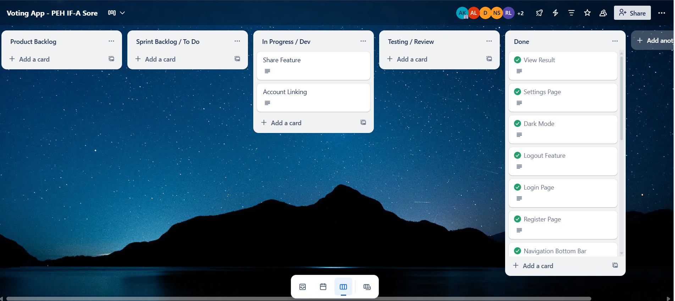

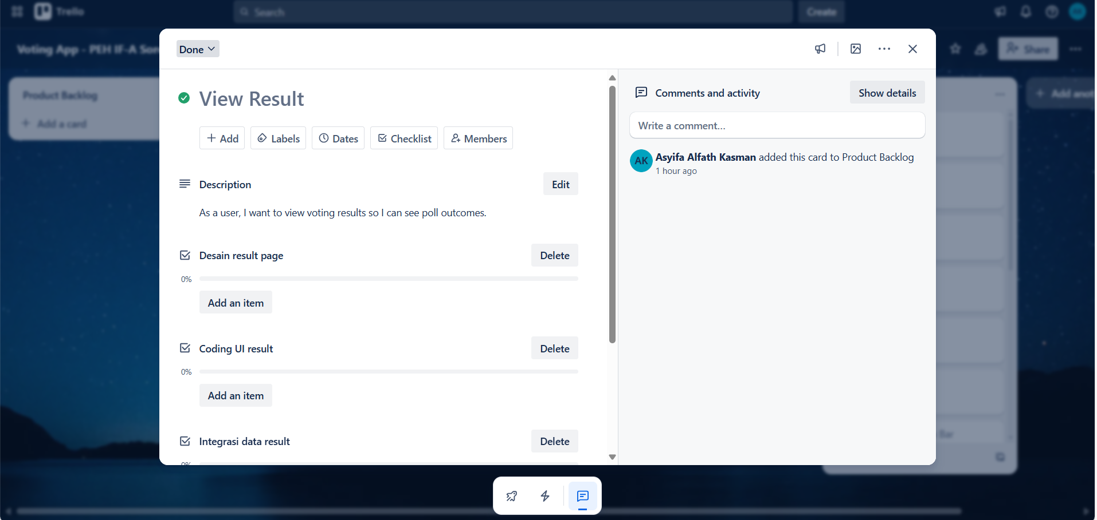 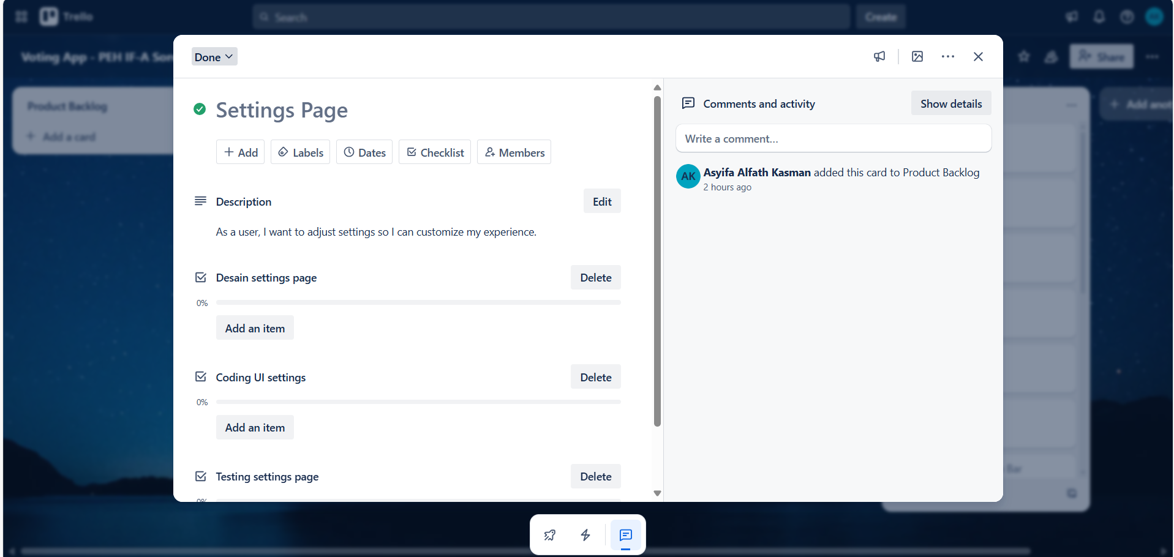 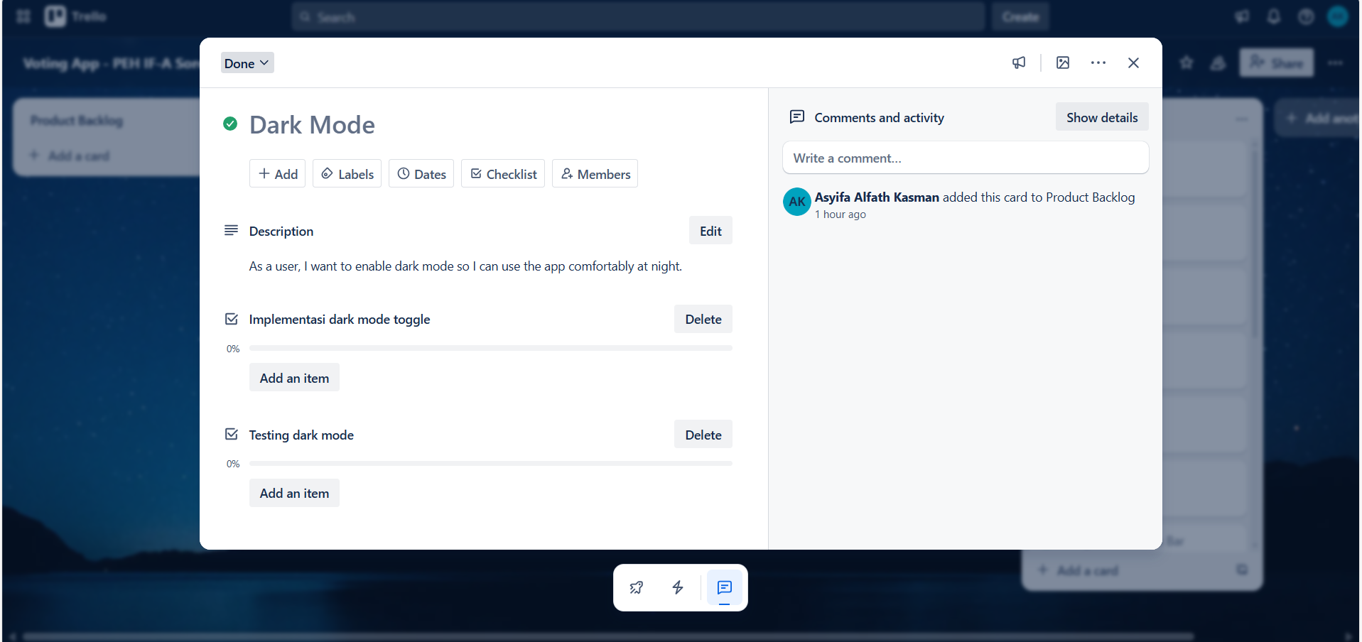 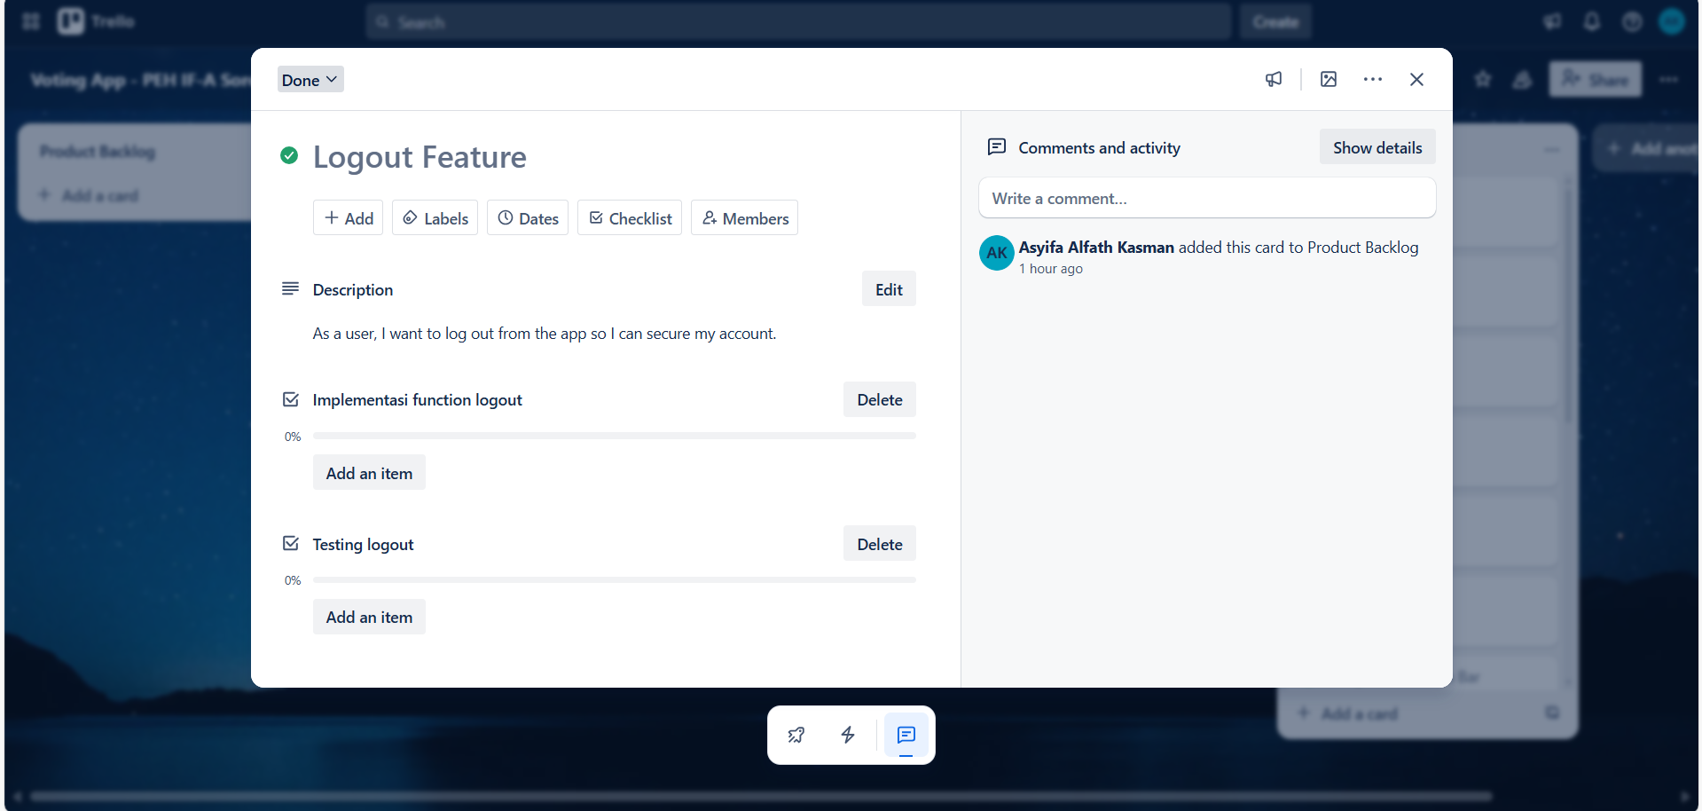 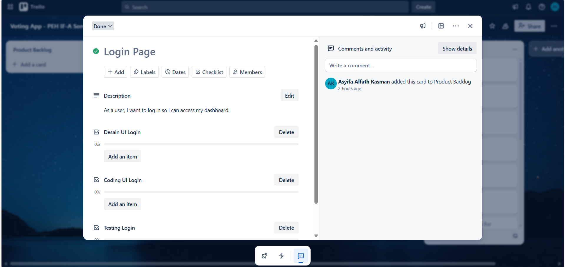 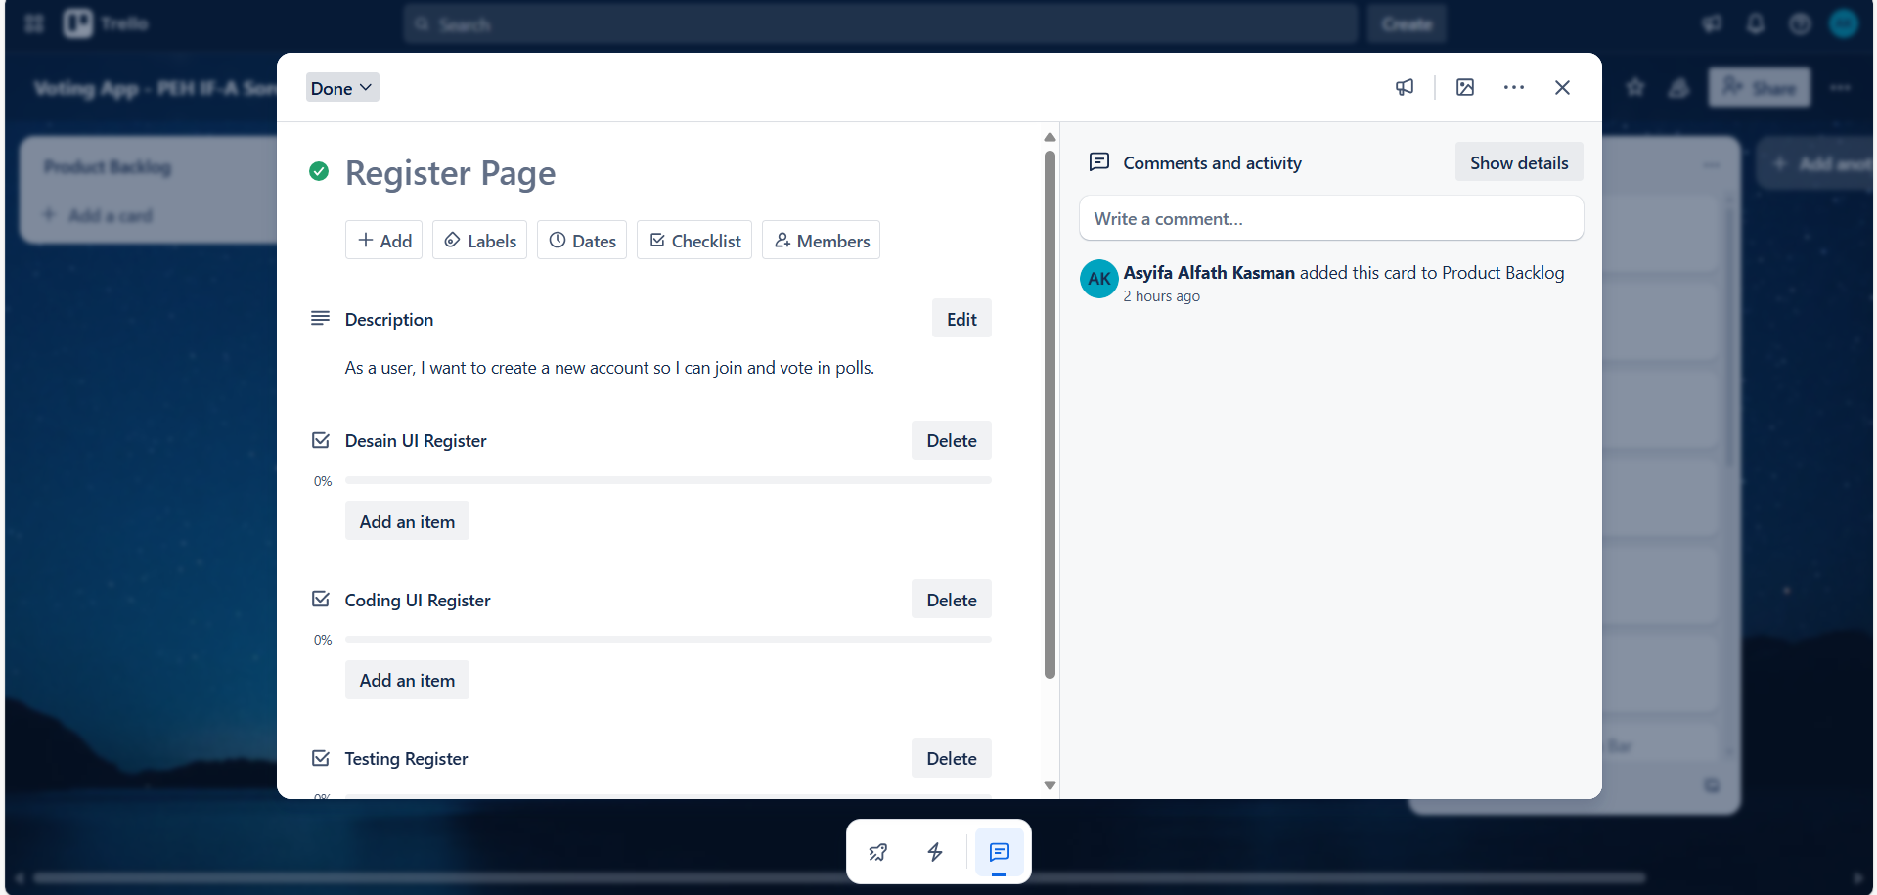 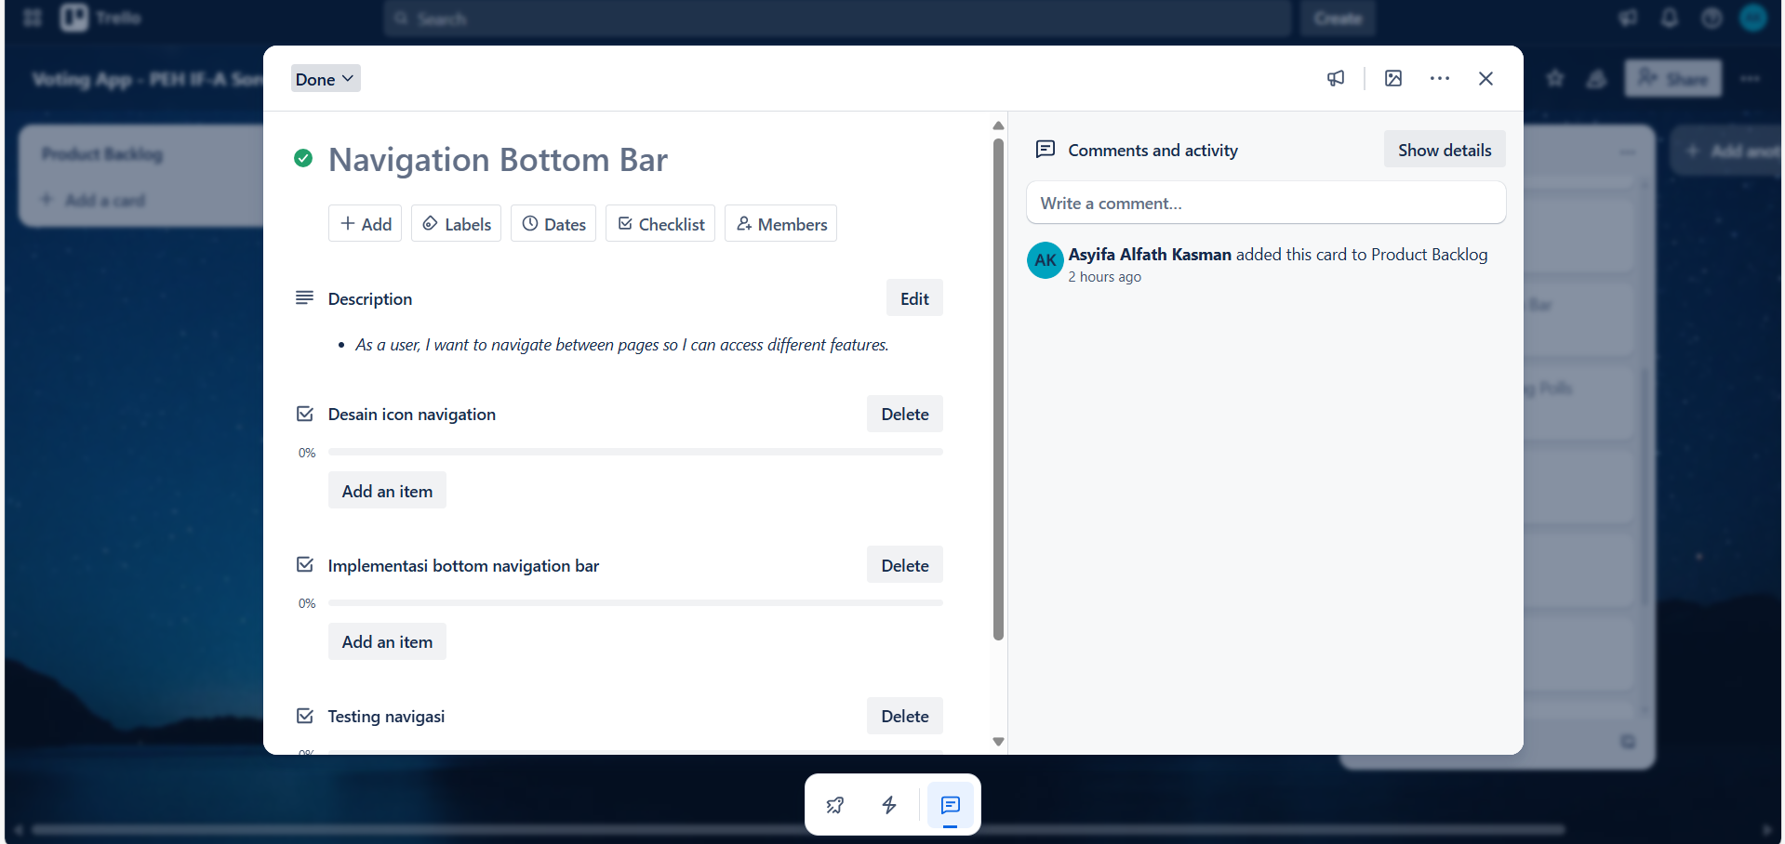 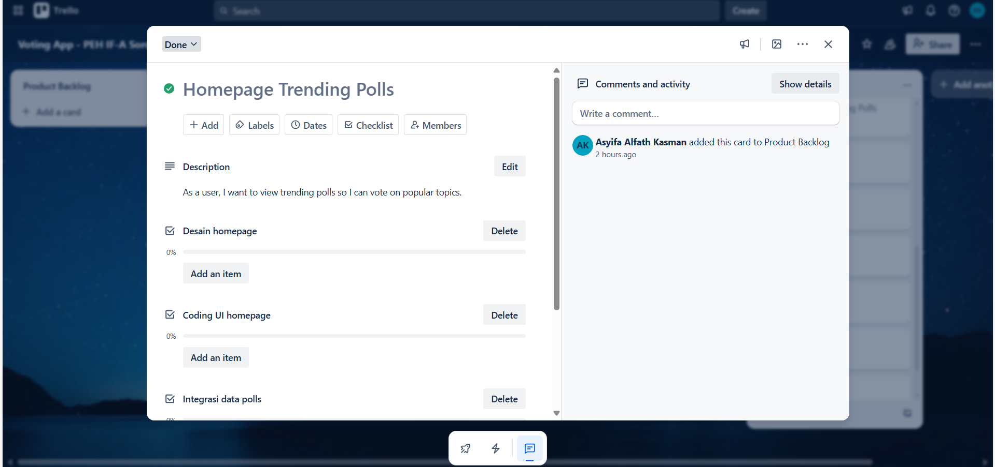 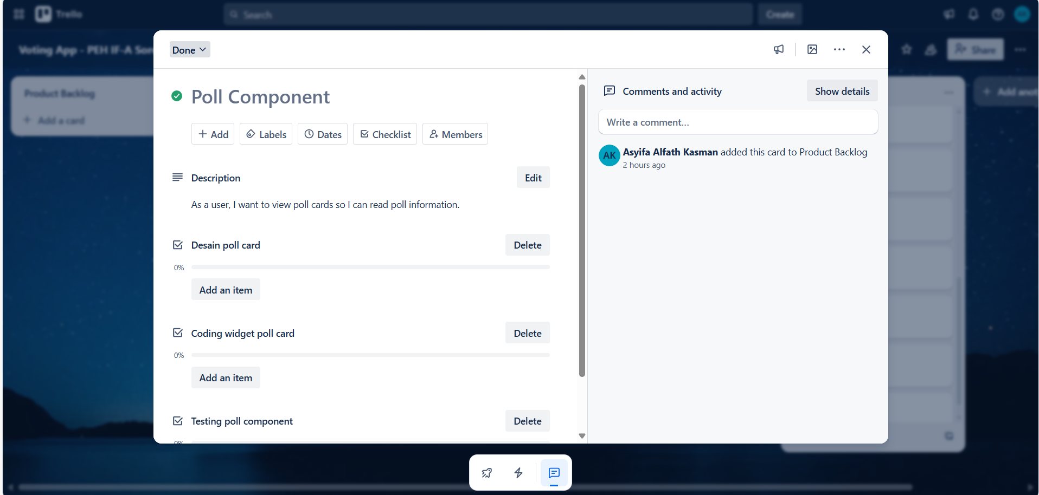 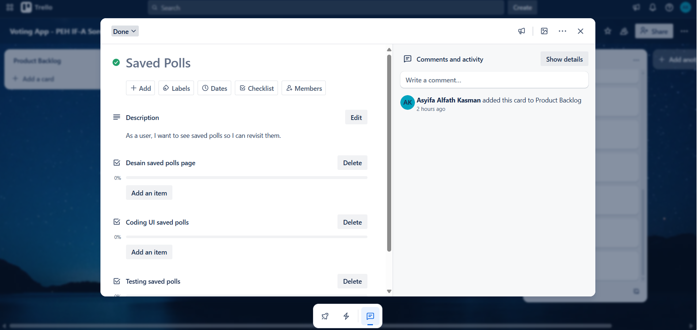 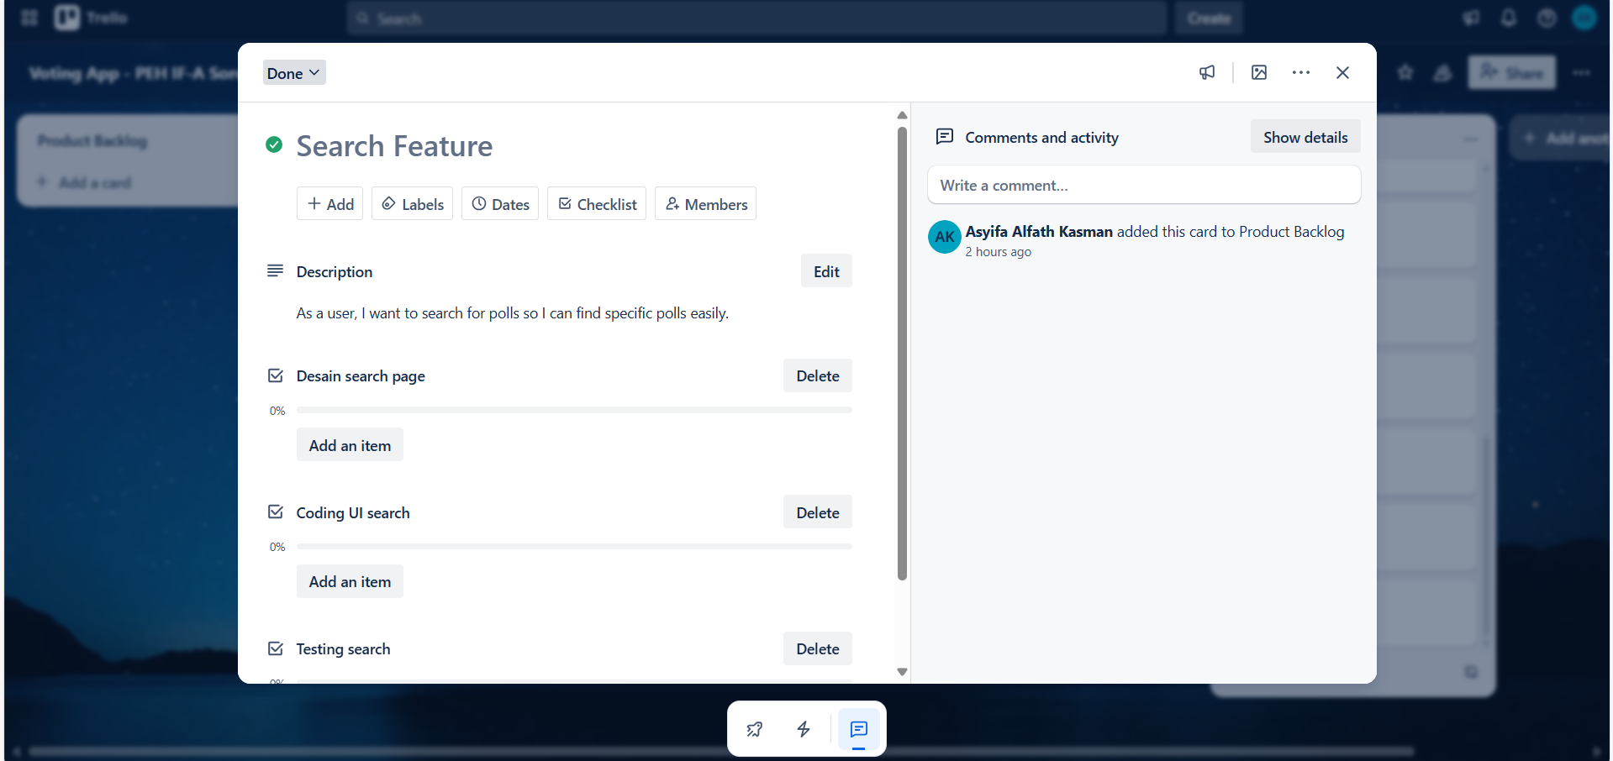 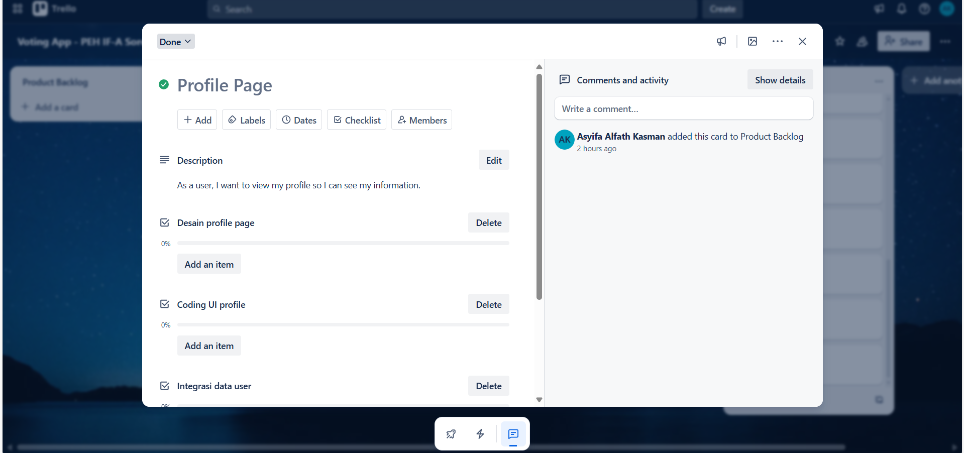 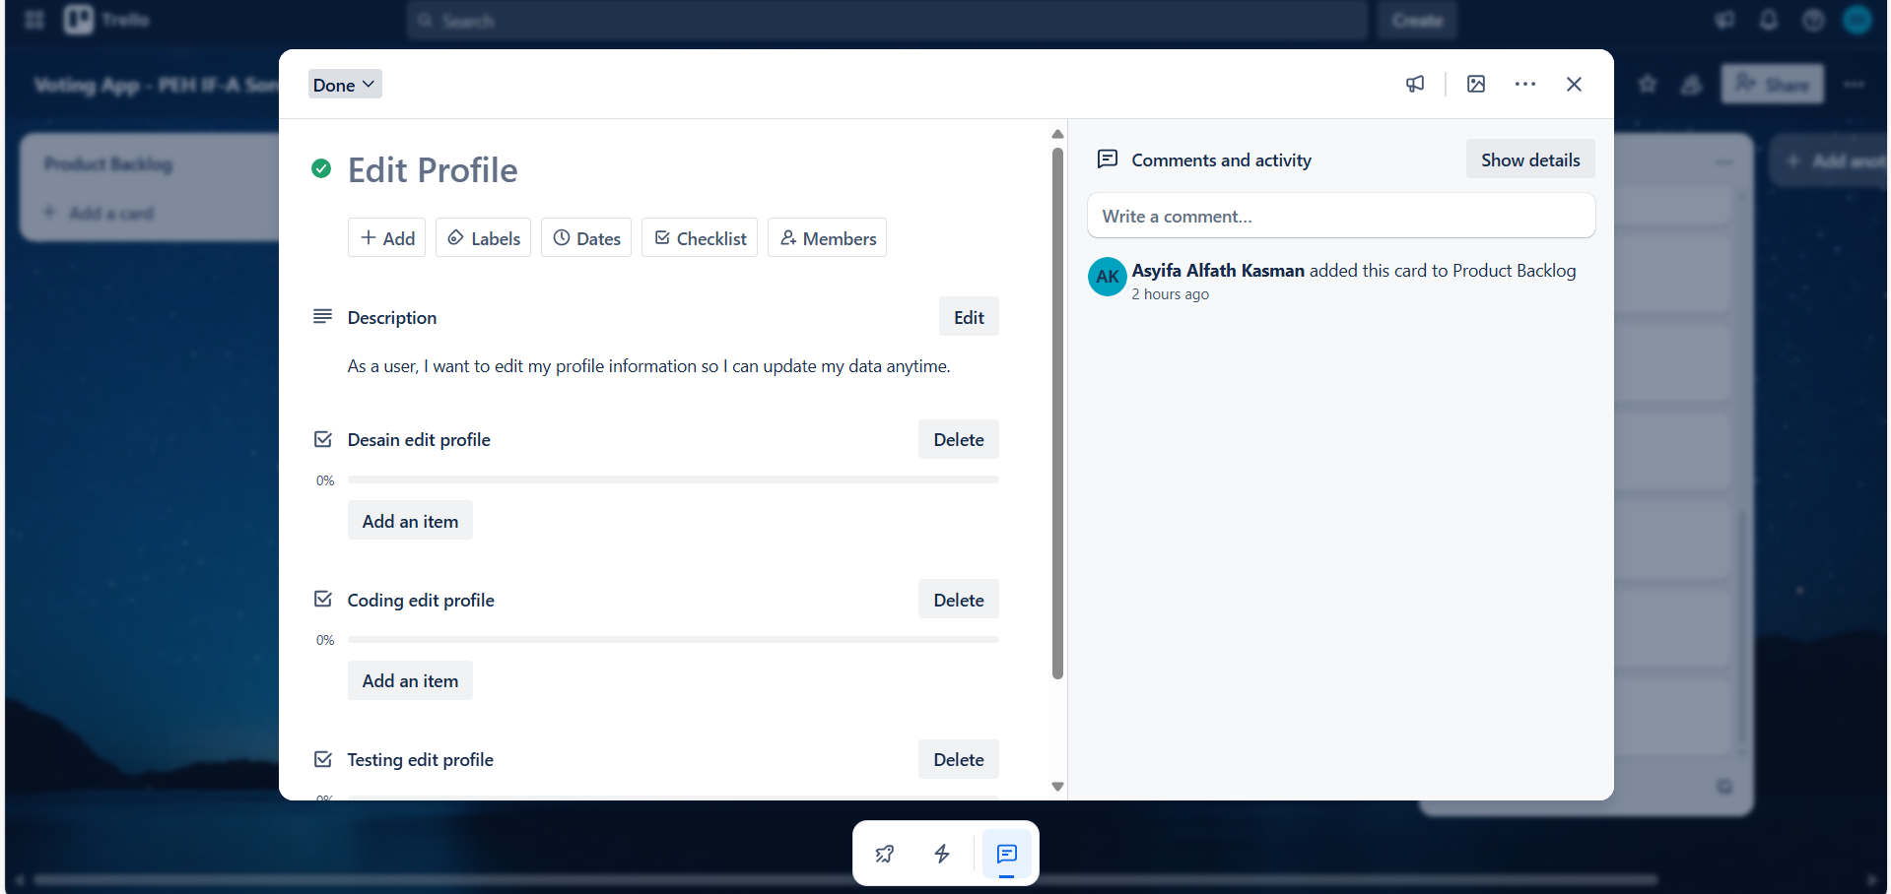 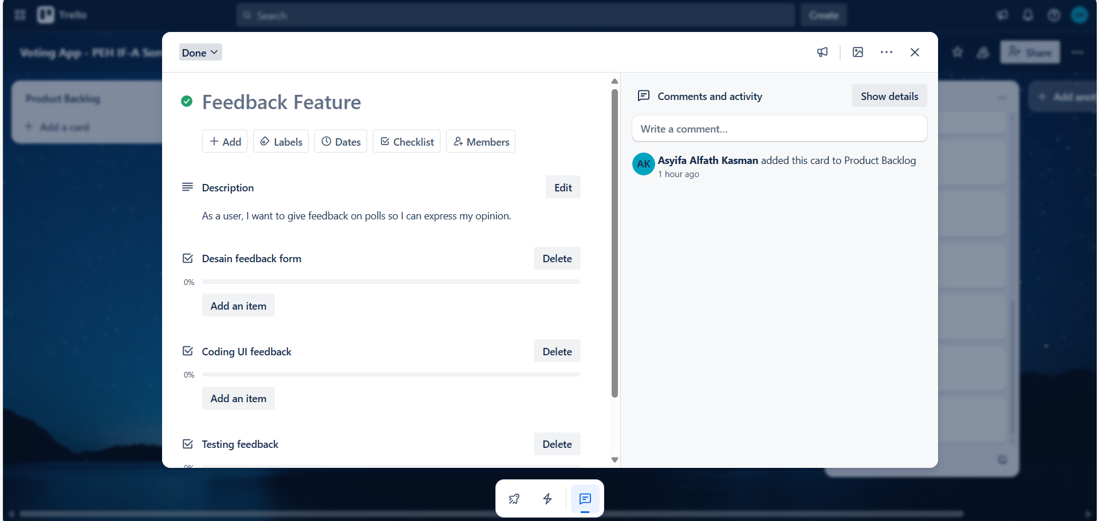 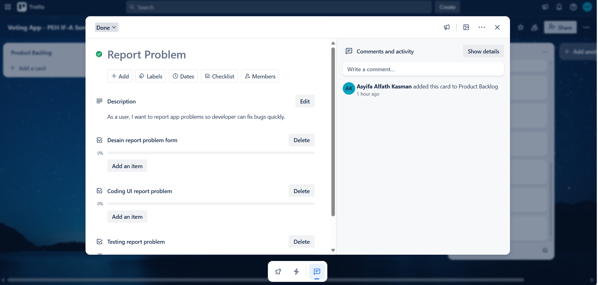

Link Trello Board: https://trello.com/invite/b/686a665a10e2b6c7c8b24af8/ATTIaa0cf693f3dda363e34bab9e0dfa3d707A53EFD0/voting-app-peh-if-a-sore

Nama Workspace: Voting App - PEH IF-A Sore

## 3.2 Github

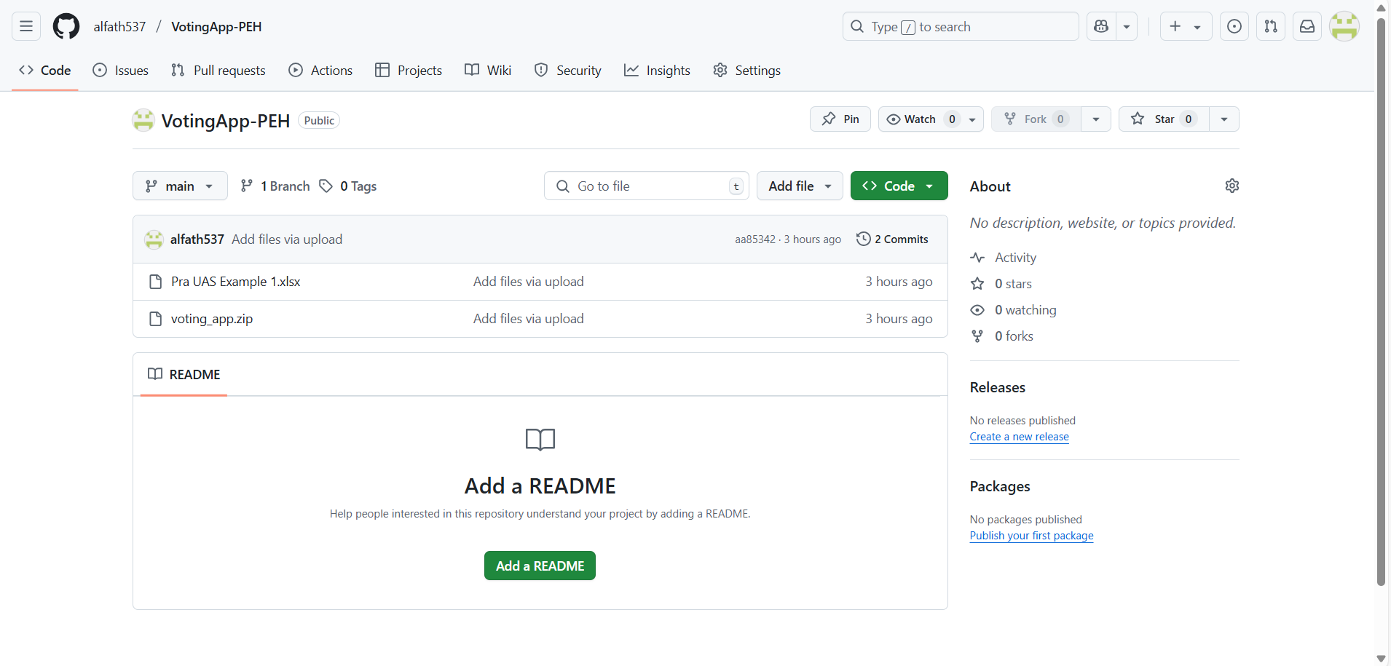

Link Github : [alfath537/VotingApp-PEH](https://github.com/alfath537/VotingApp-PEH)

Username masing masing anggota:

Asyifa Alfath Kasman : alfath537

Ahmad Danu : danu-ahmd

Derry : DERRY2309

Sherly : sherlyangelinazalukhu

Richi Putra Lin : RichiPutra123